

KG ERP USER MANUAL

**Prepared by: IT Department, Krishibid Group**

Content

Introduction 4

Description of the System 4

1. Dashboard 5

**1.1 ERP Login Page** 5

**1.2 ERP Home Page** 6

2. Setting (Feed) 7

**2.1 Product Category** 7

**2.2 Product Sub Category** 8

**2.3 Product List** 9

**2.4 Product Sale Price** 10

**2.5 RM Category** 11

**2.6 RM Sub Category** 11

**2.7 Raw Materials** 12

**2.8 Product Formula** 13

**2.9 District** 14

**2.10 Upazila** 15

**2.11 Work Area Assign** 16

**2.12 Customers** 17

**2.13 Zone wise Marketing Officers** 18

**2.14 Zone List** 19

**2.15 Suppliers** 19

3. Board of Director (Feed) 20

**3.1 Board of Director List** 20

4. Purchase (Feed) 21

**4.1 RM Purchase Demand** 21

**4.2 Purchase Orders** 22

**4.3 Raw Material Receive** 23

**4.4 Raw Material Issue** 24

5. Shareholder (Feed) 24

**5.1 Shareholder List** 24

6. Sales & Distribution (Feed) 25

**6.1 Production Requisition** 25

**6.2 Requisition Deliver Pending** 26

**6.3 Requisition Issue Pending** 27

**6.4 Order** 27

**6.5 Delivery List** 28

**6.6 Customer Payment List** 29

**6.7 Upazila List** 30

**6.8 Product Receive** 31

**6.9 Sales Return** 31

**6.10 Stock Transfer List** 32

**6.11 Stock Receive List** 33

**6.12 Product Conversion List** 34

**6.13 Product Conversion Approval List** 35

**6.14 Stock Adjustment** 35

**6.15 RM Order** 36

**6.16 Raw Material Opening** 37

**6.17 RM Delivery** 38

**6.18 Finish Product Opening** 38

7. Reports (Feed) 39

**7.1 Finish Product Stock** 39

**7.2 Raw Material Stock** 39

**7.3 Product List** 40

**7.4 Date wise Sale Qty. and Amount** 40

**7.5 Item wise Sale Status** 41

**7.6 Monthly Sale Item wise** 41

**7.7 Production Report Date Range wise** 42

**7.8 MRR Search Date wise Report** 42

**7.9 Depot wise Sale** 43

**7.10 Depot wise Stock Transfer** 43

**7.11 Item wise Stock Transfer** 44

**7.12 Customer Report** 44

**7.13 Glory Support Report** 45

8. Accounting (Feed) 45

**8.1 Chart of Accounts** 45

**8.2 Voucher List** 46

9. Accounting Reports (Feed) 47

**9.1 General Ledger** 47

**9.2 Balance Sheet** 47

**9.3 Profit & Loss** 48

**CONFIDENTIALITY NOTICE**

This documentation is proprietary information of a KRISHIBID GROUP and is not to be copied, reproduced, lent or disposed of, nor used for any purpose other than that for which it is specifically provided without the written permission of Krishibid Group.

©2019 KRISHIBID GROUP ERP all rights reserved. The unauthorized possession, use, reproduction, distribution, display or disclosure of this material or the information contained herein is prohibited.

|  |  |
| --- | --- |
|  | **KRISHIBID GROUP ERP** |
| **Owner:** | **KRISHIBID GROUP** |
| **Created:** | **July 30, 2020** |
| **Document Type:** | **Software User Manual Documentation (Krishibid Feed)**  **(Krishibid Group ERP)** |
| **Version:** | **2.0 (Final)** |

|  |  |  |  |
| --- | --- | --- | --- |
| **Revision information** | | | |
| Rev. | Author | Date | Description |
| 1.0 | Dil Afroza Ahmed Choudhury | March 15, 2020 | Document created |
| 2.0 | Dil Afroza Ahmed Choudhury | June 26, 2020 | Document created |

|  |  |  |  |
| --- | --- | --- | --- |
| **Related documents** | | | |
| Rev. | Document ID | Document name | Comments |
| 1.0 | 1.0 | User Manual (Feed) | Version 1 |
|  |  |  |  |

# Introduction

The Krishibid Group has initiated development of Enterprise Resource Planning (ERP) with the essence of establishing an effective database, to address and strengthen existing information system through coordinating and networking of existing human resource data collection systems. Krishibid consulted a team of experts, department of IT of Krishibid Group to take the responsibility of developing, implementing and maintaining ERP system in this organization. **As for any big system development the process is not an overnight thing.** HRMS is evolving, though with a remarkable speed, the inputs of stakeholders are all time required. This manual outlines the systematic procedures for accessing and using various parts of the system.

In case you do not get the assistance, you expected from the manual please consult your system administrator or any person authorized to work as the member of the helpdesk team at your organization.

# Description of the System

The following part is intended to give user an insight on how to use the system and access different features and system components.

# 1. Dashboard

## **1.1 ERP Login Page**

Open the browser and type the following address: http:// [http://192.168.0.7:90](http://192.168.0.7:90/) then a page similar to the one shown in the image below will be displayed whereby a user will be required to type in their correct **username** and **password**. This system works best with Google Chrome, Mozilla Firefox, Microsoft Edge or Opera browsers. From here on, the use of the word “browser” will refer to above mentioned web browsers only.

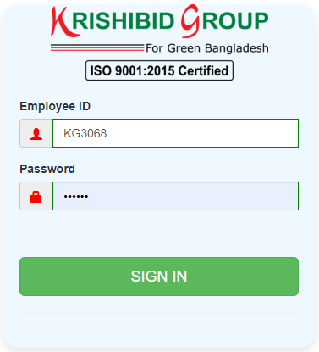

**Figure: 01 ERP Login**

**Logging on ERP System:**

* **Step-1:** Provide Valid **Username and Password. For Username Always Provide your Employee ID. (Example: EmployeeId: KGXXXX, Password: KGXXXX) with UPPERCASE.**
* **Step-2:** Click on **‘Sign In’** button for go to Home page of ERP.

## **1.2 ERP Home Page**

On successful login, a user is directed to the Home Page which consists of the main menu on the left side named dashboard. At the top most part of the system you will have on your left a home icon to denote the home page, a help button- which contains this help manual and the Employee Id of the user currently accessing the system.

The following figure (Fig-02) shows menu bar and home page.

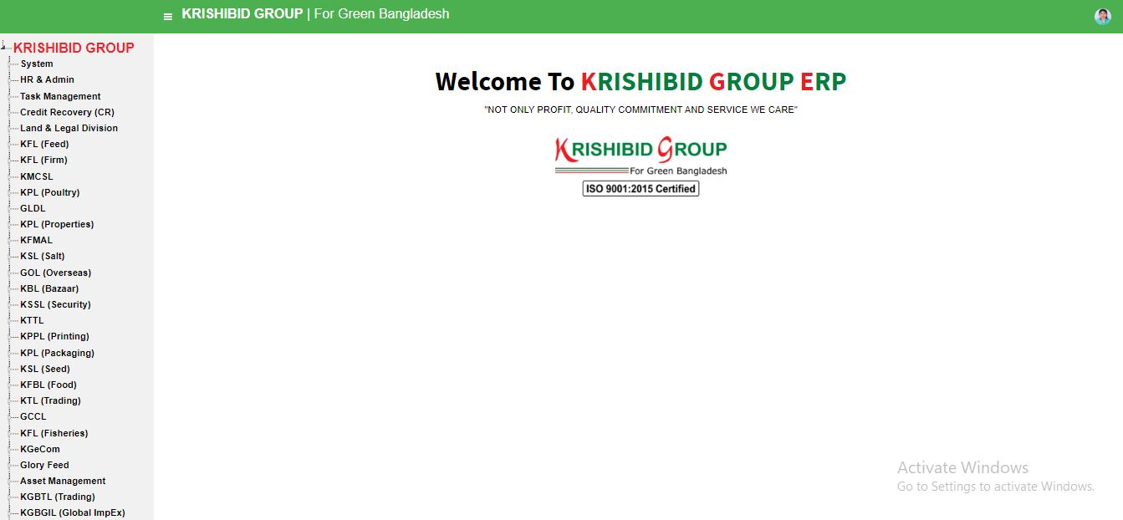

**Figure: 02 ERP Home Page**

* **Step-01:** Click on the Dashboard section under main navigation panel of Krishibid Group ERP.

# 2. Setting (Feed)

## **2.1 Product Category**

**Figure: 03 Product Category**

The following figure (Fig-03) shows options for Product Category.

* **Step-01:** Click on the **Product Category** section under **Settings (Feed) Menu** option. The following figure (Fig-03) shows the **Product Category of Feed** page.
* Step-02: Click on Add Category button to add new category on the list.
* 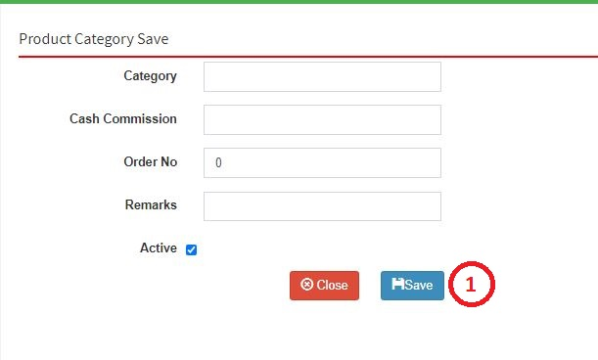Step-03: Authorized person can update product category name.

**Figure: 04 Product Category Entry Page**

* **Step-02:** Enter any “Category”, **“Cash Commission”, “Order No”, “Remarks”,** Click on Active button to save new product category.

## **2.2 Product Sub Category**

**Figure: 05 Product Sub Category**

The following figure (Fig-05) shows options for Product Sub Category.

* **Step-01:** Click on the **Product Sub Category** section under **Settings (Feed) Menu** option. The following figure (Fig-03) shows the **Product Sub Category of Feed** page.
* **Step-02:** Click on Add button to add new sub category on the list. Enter any **“Category” or “Sub Category”** in the search section and click “Enter” button to search any product.

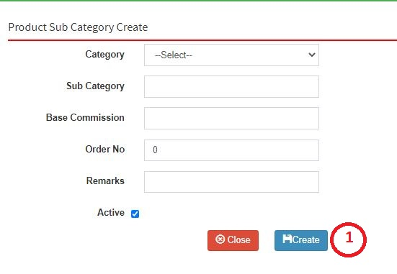

* **Figure: 6 Create Product Sub Category**
* **Step-01:** Enter any **“Category”, “Sub Category”, “Base Commission”, “Order No”, “Remarks”, Check Active button** in the new sub category entry page and click “Create” button to save any new Sub category under the Category.

## **2.3 Product List**

**Figure: 7 Product List**

The following figure (Fig-07) shows options for Product.

* **Step-01:** Click on the **Product** section under **Settings (Feed) Menu** option. The following figure (Fig-03) shows the **Product of Feed** page.
* 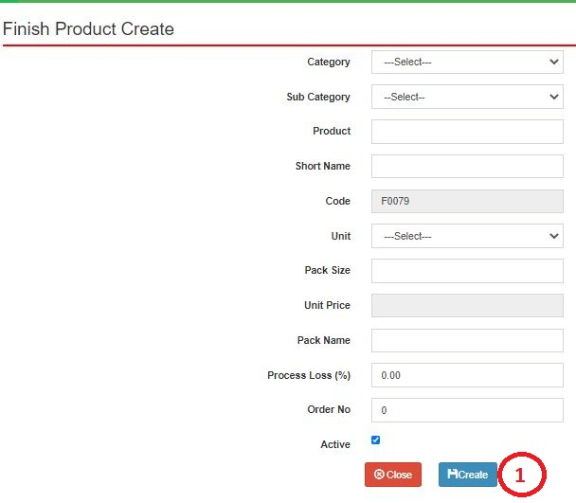**Step-02:** Click on Add Product button to add new product on the list. Enter any **“Category” or “Sub Category” or “Product”** in the search section and click “Enter” button to search any product.

**Figure: 8 Product Entry Page**

* **Step-02:** Enter **‘Category’, ‘Sub Category’, ‘Product’, ‘Short Name’, ‘Unit’, ‘Pack Size’, ‘Pack Name’, ‘Process Loss(%)’, ‘Order No’, ‘Check on Active button’** and click “Create” button to save any new product.

## **2.4 Product Sale Price**

**Figure: 9 Product Sale Price**

The following figure (Fig-09) shows options for Product Sale Price.

* **Step-01:** Click on the **Product Sale Price** section under **Settings (Feed) Menu** option. The following figure (Fig-03) shows the **Product of Feed** page.
* **Step-02:** Click on Add button to add new product sale price on the list. Enter any **“Date” or “Product”** in the search section and click “Enter” button to search any products Sale price.

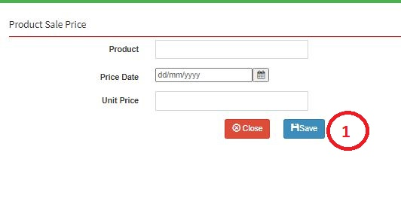

* **Figure: 10 Product Sale Price Entry Page**
* **Step-02:** Enter **‘Product’, ‘Price Date’, ‘Unit Price’** and click “Submit” button to save any new Product Sale Price.

## **2.5 RM Category**

**Figure: 11 RM Category**

The following figure (Fig-11) shows options for RM Category.

* **Step-01:** Click on the **RM Category** section under **Settings (Feed) Menu** option. The following figure (Fig-03) shows the **Product of Feed** page.
* **Step-02:** Click on Add Category button to add new rm category on the list. Enter any **“Category”** in the search section and click “Enter” button to search any new RM Category.



**Figure: 12 RM Category Entry Page**

* 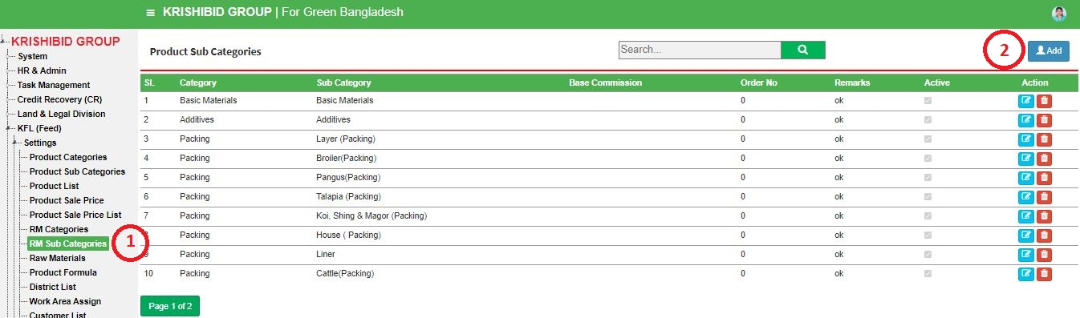**Step-02:** Enter **‘Category’, ‘Cash Customer’, ‘Order No’, ‘Remarks’ (If Any)** and click “Save” button to save any new RM Category.

## **2.6 RM Sub Category**

**Figure: 13 RM Sub Category**

The following figure (Fig-13) shows options for RM Sub Category.

* **Step-01:** Click on the **RM Sub Category** section under **Settings (Feed) Menu** option. The following figure (Fig-03) shows the **Product of Feed** page.
* 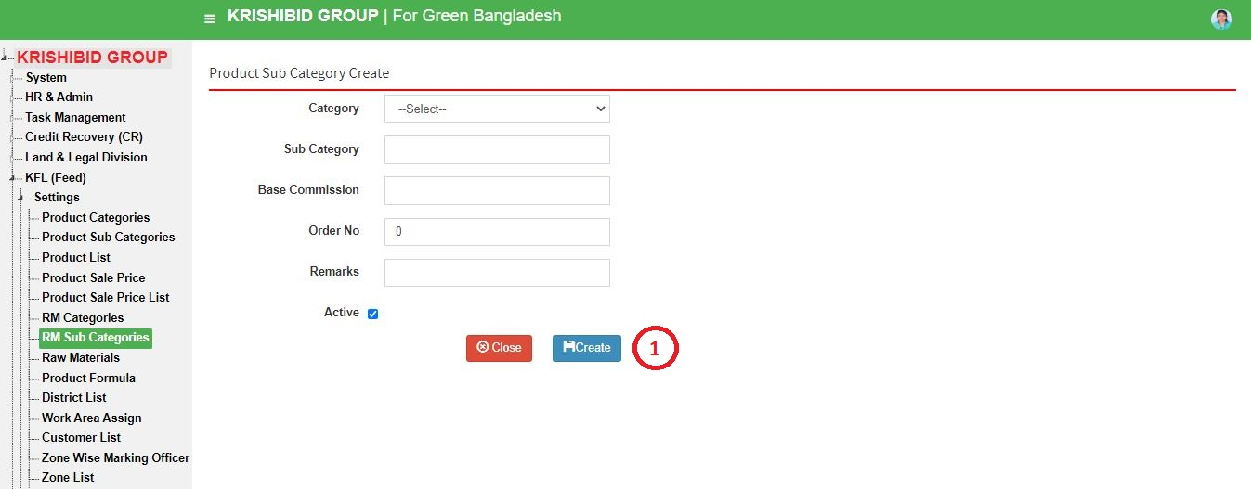**Step-02:** Click on Add button to add new rm sub category on the list. Enter any **“Category”, ‘Sub Category’ or “Base Commission”** in the search section and click “Enter” button to search any products Sale price.

**Figure: 14 RM Sub Category Entry Page**

* **Step-02:** Enter **‘Category’, ‘Sub Category’, ‘Base Commission’, ‘Order No’, ‘Remarks’ (If Any)** and click “Create” button to save any new Product Sub Category.

## **2.7 Raw Materials**

**Figure: 15 Raw Materials**

The following figure (Fig-15) shows options for RM Materials.

* **Step-01:** Click on the **Raw Material** section under **Settings (Feed) Menu** option. The following figure (Fig-03) shows the **Product of Feed** page.
* **Step-02:** Click on Add Product button to add new rm material on the list. Enter any **“Category”, “Sub Category”, “Product”, “Product Code” or “Short Name”** in the search section and click “Enter” button to search any Raw Materials.
* **Step-03:** Click on Edit and Delete Button to update or delete any Raw Material.

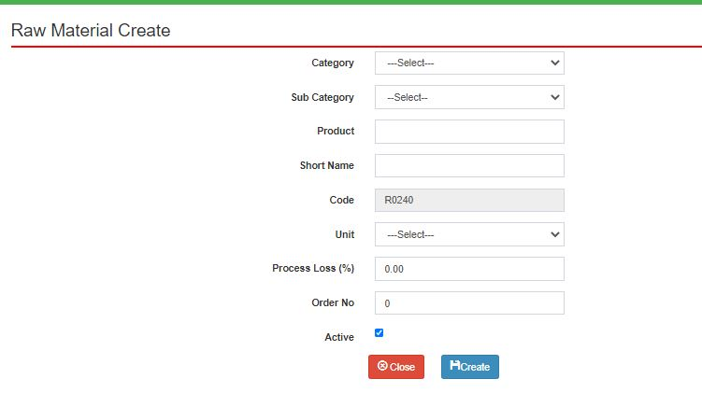

**Figure: 16 Raw Material Entry Page**

* **Step-02:** Enter **‘Category’, ‘Sub Category’, ‘Product’, ‘Short Name’, ‘Unit, ‘Process Loss’, ‘Order No**, **‘Order No’**, must be click on Active button and click “Submit” button to save any new Raw Material.

## **2.8 Product Formula**

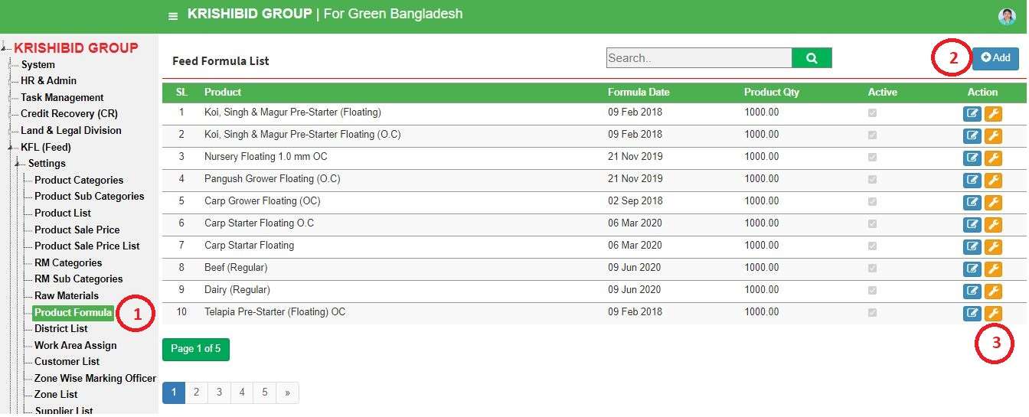

**Figure: 17 Feed Formula**

The following figure (Fig-03) shows options for RM Category.

* **Step-01:** Click on the **Feed Formula** section under **Settings (Feed) Menu** option. The following figure (Fig-03) shows the **Product of Feed** page.
* **Step-02:** Click on +Add button to add new product formula on the list. Enter any **“Formula Date” or “Product”** in the search section and click “Enter” button to search any Products Feed Formula. Click on Edit and Delete Button to update or delete any feed formula.

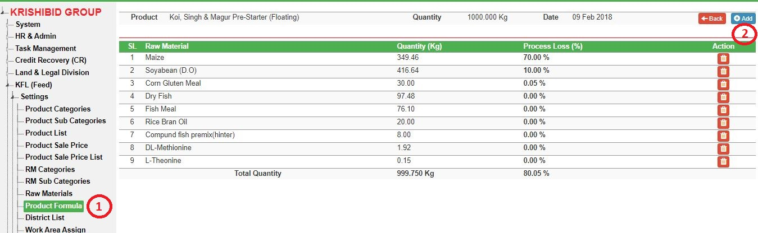

**Figure: 18 Product Formula Entry Page**

* **Step-01:** If any new raw material needed to add on formula list then click on +Add button to add new raw material in current product formula list.

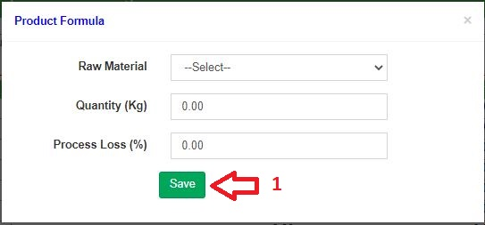

**Figure: 18 Feed Formula Entry Page for Specific item Add in formula**

## **2.9 District**

**Figure: 19 District**

The following figure (Fig-19) shows options for District.

* **Step-01:** Click on the **District** section under **Settings (Feed) Menu** option. The following figure (Fig-03) shows the **Product of Feed** page.
* **Step-02:** Enter any **“District” or “District Code”** in the search section and click “Enter” button to search any products Sale price.

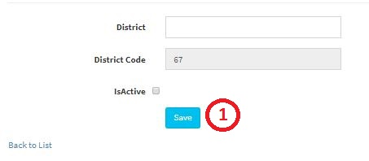

**Figure: 20 District Entry Page**

* **Step-02:** Enter **‘District’, ‘Check Active Button’** and click on “Save” button to save any new District. Must be click on Active button.

## **2.10 Upazila**

**Figure: 21 Upazila**

The following figure (Fig-03) shows options for RM Category.

* **Step-01:** Click on the **Upazila** section under **Settings (Feed) Menu** option. The following figure (Fig-03) shows the **Product of Feed** page.
* **Step-02:** Enter any **“District” or “Upazila” or “Upazila Code”** in the search section and click “Enter” button to search any Upazila. Click on Edit and Delete Button to update or delete any Upazila

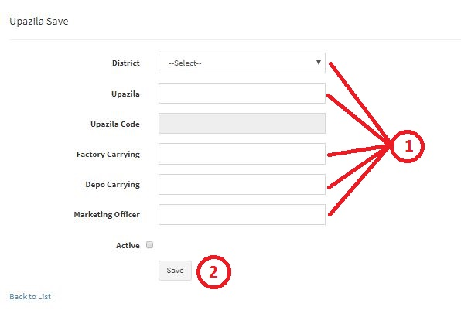

**Figure: 22 Upazila Entry Page**

* **Step-02:** Enter **‘District, ‘Upazila’, ‘Factory Carrying Cost’, ‘Depot Carrying’, ‘Marketing Officer’** and click “Submit” button to save any new Upazila. Must be click on Active button.

## **2.11 Work Area Assign**

**Figure: 23 Work Area Assign to Marketing Officer**

The following figure (Fig-03) shows options for RM Category.

* **Step-01:** Click on the **Area Assign** section under **Settings (Feed) Menu** option. The following figure (Fig-03) shows the **Product of Feed** page.
* **Step-02:** Enter **“Employee”, “District”** click on save button to save any New Assigned Area to any Marketing Officer.

## **2.12 Customers**

**Figure: 24 Customer List**

The following figure (Fig-03) shows options for RM Category.

* **Step-01:** Click on the **Customers** section under **Settings (Feed) Menu** option. The following figure (Fig-03) shows the **Product of Feed** page.
* **Step-02:** Click on +Add button to add new customer on the list. Enter any **“Customer Type” or “Name”** in the search section and click “Enter” button to search any products Sale price. Must be click on Active button. Click on Edit and Delete Button to update or delete any Customer.

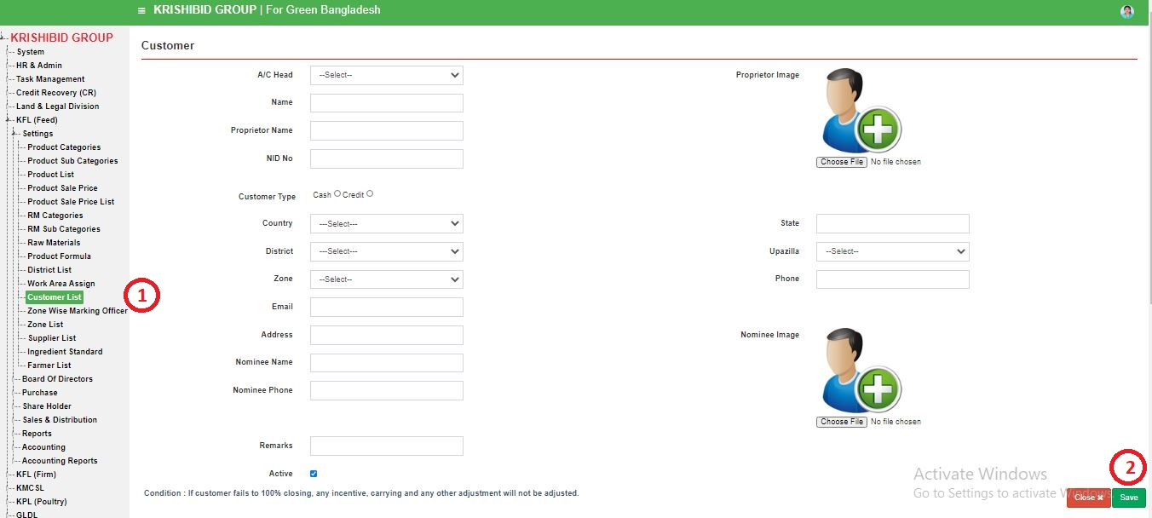

**Figure: 25 Customer Entry Page**

* **Step-02:** Enter **‘A/C Head, ‘Name’, ‘Proprietor Name’, ‘Proprietor Image, ‘Customer Type’, ‘District’, ‘Upazila’, ‘Phone’, ‘Address’, ‘Nominee Name’, ‘Nominee Image’, ‘Nominee Phone’, ‘Credit Ratio’, ‘Credit Unit’, ‘Credit Unit’, ‘Monthly Target’, ‘Yearly Target’, ‘Special Discount’, ‘Remarks’, ‘Carrying , ‘Closing Time’** and click “Save” button to save any new Customer.

## **2.13 Zone wise Marketing Officers**

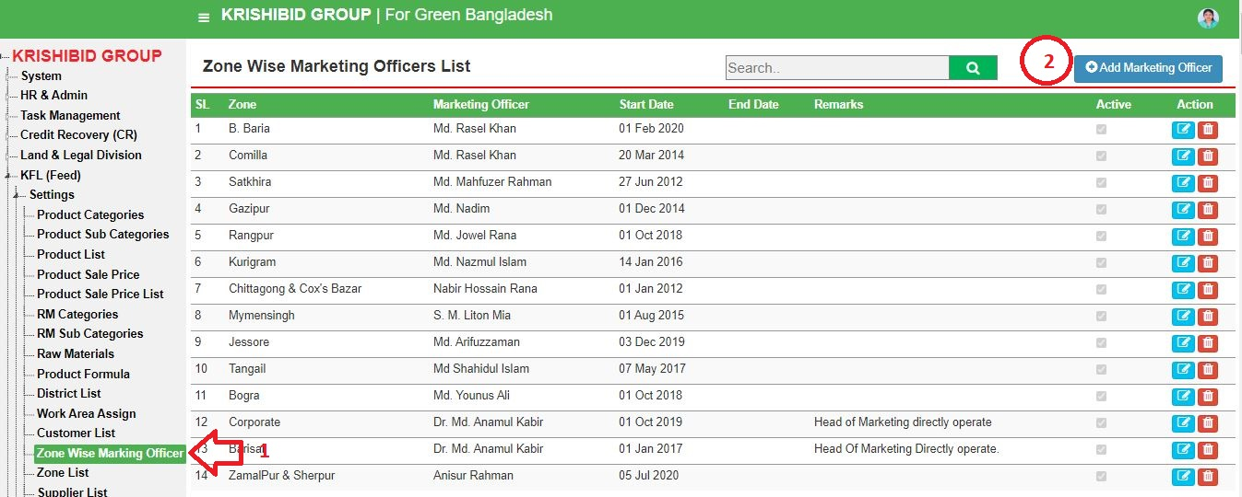

**Figure: 26 Zone wise Marketing Officer**

The following figure (Fig-26) shows options for RM Category.

* **Step-01:** Click on the **Zone wise Marketing Officer** section under **Settings (Feed) Menu** option. The following figure (Fig-03) shows the **Product of Feed** page.
* **Step-02:** Click on +Add button to add new zone wise marketing officers information on the list. Enter any **“Name” or “Code”** in the search section and click “Enter” button to search any products marketing officer. Click on Edit and Delete Button to update or delete any marketing officer.

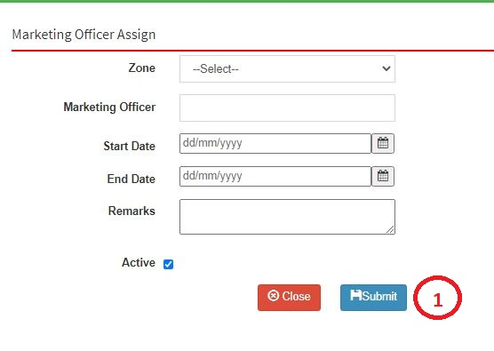

**Figure: 27 Zone wise Marketing officer Entry Page**

* Enter **‘Zone’, ‘Marketing Officer’, ‘Start Date, ‘Remarks’, ‘Active’** and click “Save” button to save any new Marketing Officer Assign.

## **2.14 Zone List**

**Figure: 28 Zone List**

The following figure (Fig-28) shows options for RM Category.

* **Step-01:** Click on the **Zone List** section under **Settings (Feed) Menu** option. The following figure (Fig-03) shows the **Product of Feed** page.
* **Step-02:** Click on +Add button to add new zone on the list. Enter any **“Name” or “Code”** in the search section and click “Enter” button to search any zone. Click on Edit and Delete Button to update or delete any zone.

## **2.15 Suppliers**

**Figure: 26 Suppliers**

The following figure (Fig-03) shows options for RM Category.

* **Step-01:** Click on the **Supplier** section under **Settings (Feed) Menu** option. The following figure (Fig-03) shows the **Product of Feed** page.
* 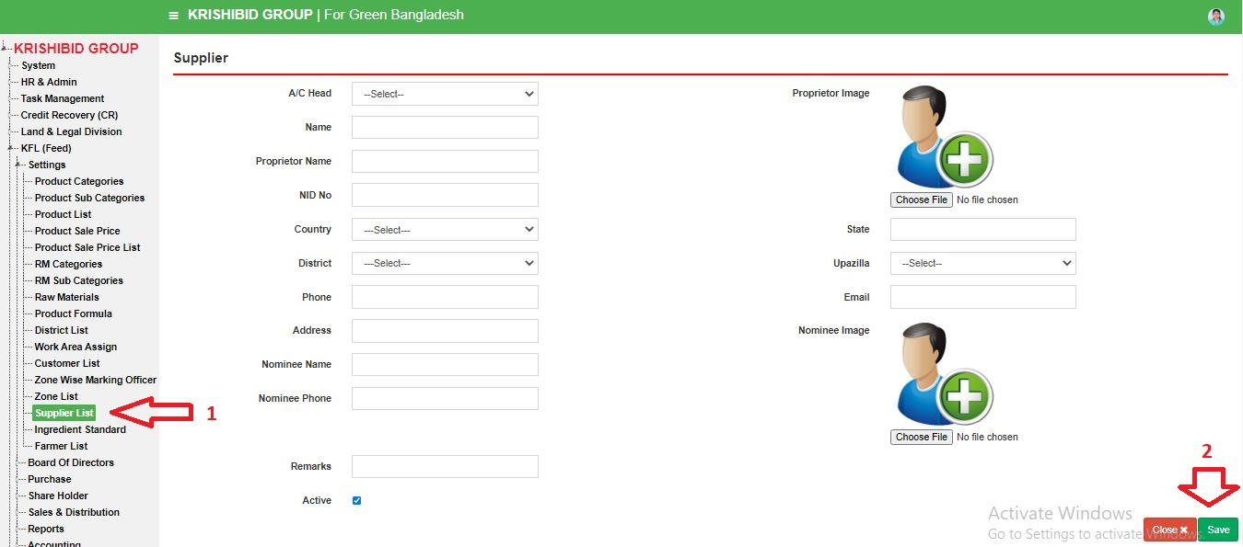**Step-02:** Click on +Add button to add new supplier on the list. Enter any **“Name” or “Code”** in the search section and click “Enter” button to search any products Supplier. Click on Edit and Delete Button to update or delete any Supplier.

**Figure: 27 Suppliers Entry Page**

* Enter **‘A/C Head, ‘Name’, ‘Proprietor Name’, ‘Proprietor Image, ‘Customer Type’, ‘District’, ‘Upazila’, ‘Phone’, ‘Address’, ‘Nominee Name’, ‘Nominee Image’, ‘Nominee Phone’ ‘Remarks’, ‘Closing Time’** and click “Save” button to save any new Supplier.

# 3. Board of Director (Feed)

## **3.1 Board of Director List**

**Figure: 29 Board of Directors**

The following figure (Fig-29) shows options for **Board of Director**.

* **Step-01:** Click on the **Board of Director List** section under **Board of Director Menu** option. The following figure (Fig-03) shows the **Product of Feed** page.
* **Step-02:** Click on +Add button to add new board of director on the list. Enter any **“Member Name”** in the search section and click “Enter” button to search any **Board of Director**. Click on Edit and Delete Button to update or delete any **Board of Director**.

# 4. Purchase (Feed)

## **4.1 RM Purchase Demand**

**Figure: 30 RM Purchase Demand**

The following figure (Fig-29) shows options for **RM Purchase Demand**.

* **Step-01:** Click on the **RM Purchase Demand List** section under **RM Purchase Demand Menu** option. The following figure (Fig-03) shows the **Product of Feed** page.
* **Step-02:** Click on +New Demand button to add new **RM Purchase Demand** on the list. Enter any **“Member Name”** in the search section and click “Enter” button to search any **RM Purchase Demand**. Click on Edit and Delete Button to update or delete any **RM Purchase Demand**.

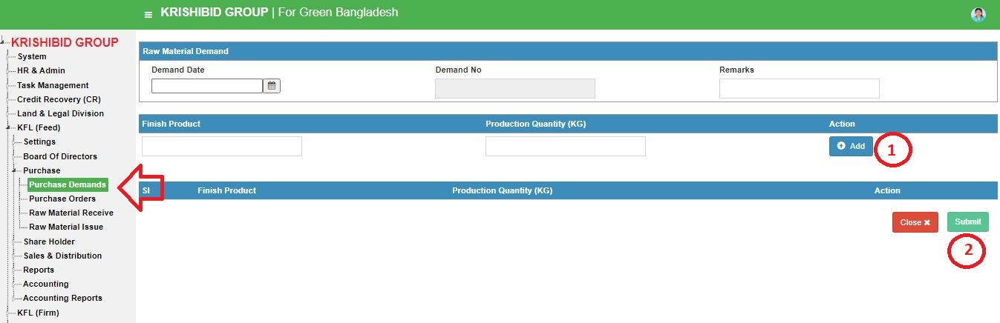**Figure: 30 RM Purchase Demand Entry Page**

* **Step-01:** Enter any **“Demand Date”, “Finish Product”, “Production Quality” and click on +Add button** then click on Submit button to add new rm demand.

## **4.2 Purchase Orders**

**Figure: 31 Purchase Orders**

The following figure (Fig-29) shows options for **Purchase Orders**.

* **Step-01:** Click on the **Purchase Orders List** section under **Purchase Orders Menu** option. The following figure (Fig-03) shows the **Product of Feed** page.
* 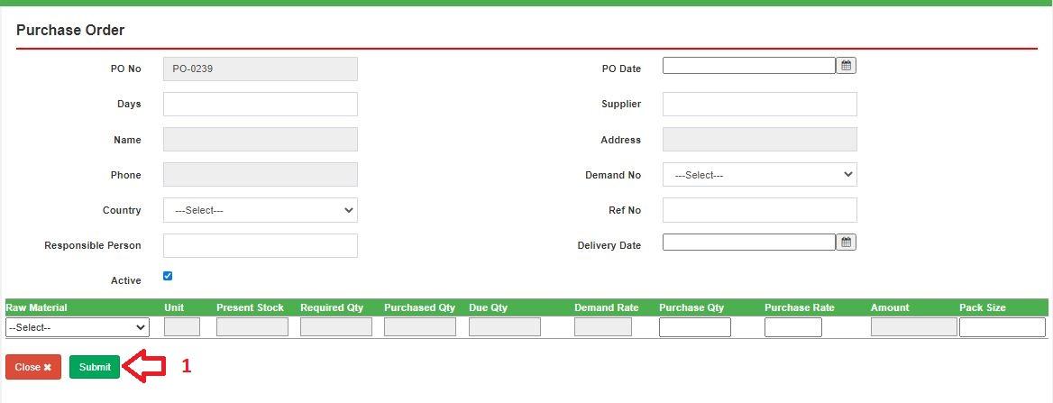**Step-02:** Click on +New Demand button to add new **Purchase Orders** on the list. Enter any **“Member Name”** in the search section and click “Enter” button to search any **Purchase Orders**. Click on Edit and Delete Button to update or delete any **Purchase Orders**.

**Figure: 32 Purchase Orders Entry Page**

* **Step-01:** Enter any **“PO Date”, ”Days”, ”Supplier”, ”Demand No”, “Country”, “Reference No”, “Responsible Person”, “Delivery Date”, “Check Active Status”, “Raw Material”, “Purchase Qty”, “Purchase Rate”, “Pack Size” and click on +Add button** then click on Submit button to add new purchase order.

## **4.3 Raw Material Receive**

**Figure: 32 Raw Material Receive**

The following figure (Fig-29) shows options for **Raw Material Receive**.

* **Step-01:** Click on the **Raw Material Receive List** section under **Raw Material Receive Menu** option. The following figure (Fig-03) shows the **Product of Feed** page.
* 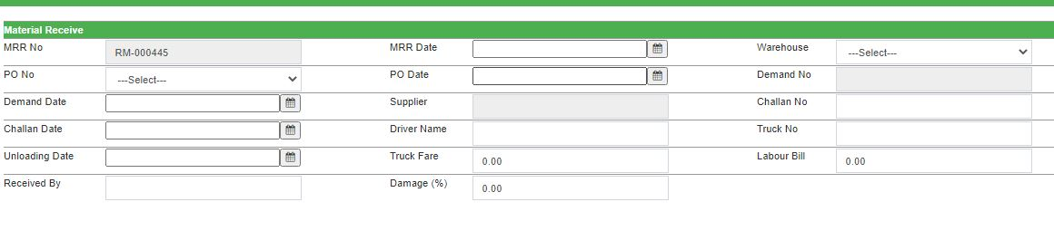**Step-02:** Click on +New Receive button to add new **Raw Material Receive** on the list. Enter any **“Member Name”** in the search section and click “Enter” button to search any **Raw Material Receive**. Click on Edit and Delete Button to update or delete any **Raw Material Receive**.

**Figure: 33 Raw Material Receive Entry Page**

* **Step-01:** Enter any **“MRR Date”, ”Warehouse”, ”PO No”, ”PO Date”, “Demand Date”, “Challan No”, “Challan Date”, “Driver Name”, “Truck No”, “Unloading Date”, “Truck Fare”, “Labour Bill”, “Received By”, “Damage(%)” and click on +Add button** then click on Submit button to add new raw material receive.

## **4.4 Raw Material Issue**

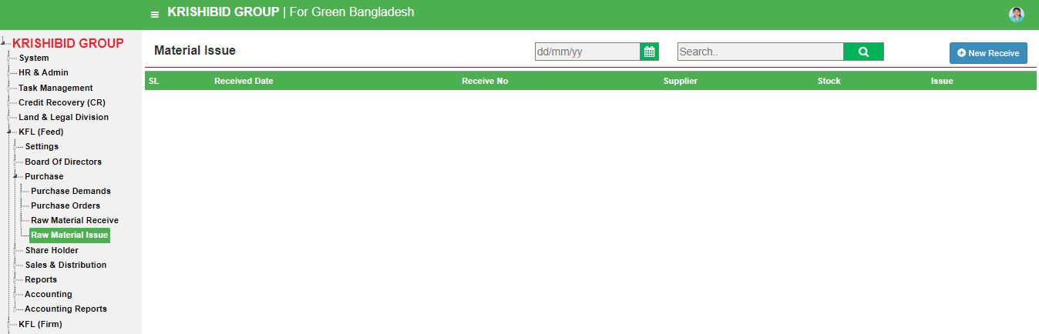

**Figure: 34 Raw Material Issue**

The following figure (Fig-29) shows options for **Raw Material Issue**.

* **Step-01:** Click on the **Raw Material Issue List** section under **Raw Material Issue Menu** option. The following figure (Fig-03) shows the **Product of Feed** page.
* 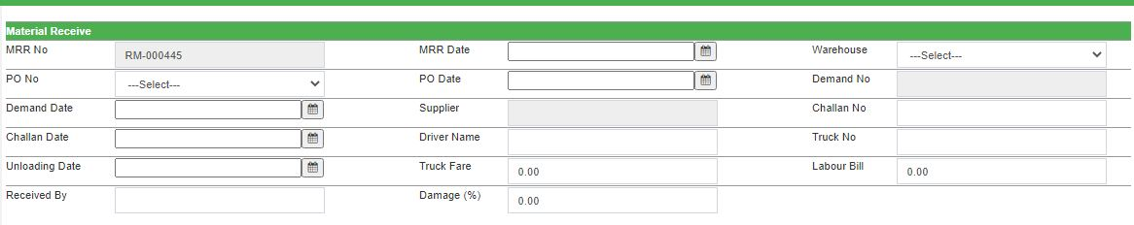**Step-02:** Click on +New Receive button to add new **Raw Material Issue** on the list. Enter any **“Member Name”** in the search section and click “Enter” button to search any **Raw Material Issue**. Click on Edit and Delete Button to update or delete any **Raw Material Issue**.

**Figure: 35 Raw Material Issue Entry Page**

* **Step-01:** Enter any **“MRR Date”, ”Warehouse”, ”PO No”, ”PO Date”, “Demand Date”, “Challan No”, “Challan Date”, “Driver Name”, “Truck No”, “Unloading Date”, “Truck Fare”, “Labour Bill”, “Received By”, “Damage(%)” and click on +Add button** then click on Submit button to add new raw material issue.

# 5. Shareholder (Feed)

## **5.1 Shareholder List**

**Figure: 36 Shareholder List**

The following figure (Fig-36) shows options for **Shareholder List**.

* **Step-01:** Click on the **Shareholder List** section under **Shareholder Menu** option. The following figure (Fig-03) shows the **Product of Feed** page.
* 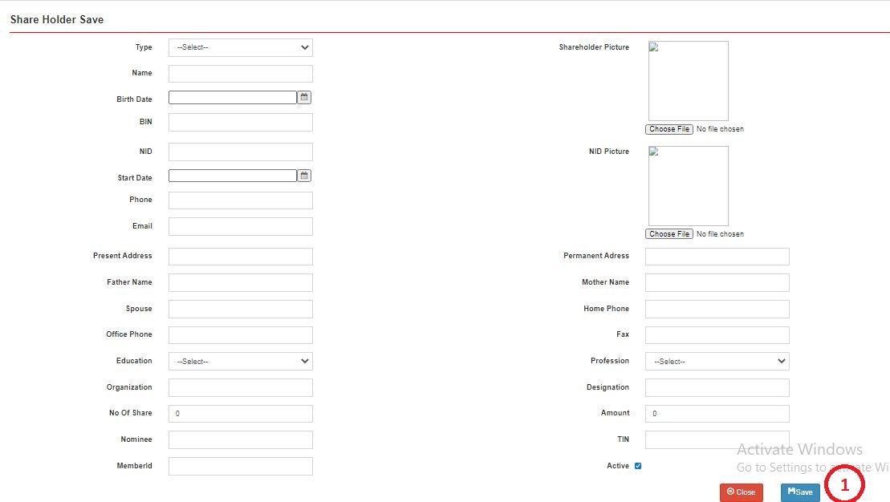**Step-02:** Click on +Add Member button to add new **Shareholder** on the list. Enter any **“Member Name”** in the search section and click “Enter” button to search **Shareholder**. Click on Edit and Delete Button to update or delete any **Shareholder**.

**Figure: 37 Shareholder Entry Page**

* **Step-01:** Enter any **“Type”, ”Picture”, ”Name”, ”Birth Date”, “BIN”, “NID”, “NID Picture”, “Start Date”, “Phone”, “Email”, “Present Address”, “Permanent Address”, “Father Name”, “Mother Name”, “Spouse”, “Home Phone”, “Office Phone”, “Fax”, “Education”, “Designation”, “No of Share”, “Amount”, “Nominee”, “TIN”, “MemberId” and click on +Save button** then click on Submit button to add new Shareholder.

# 6. Sales & Distribution (Feed)

## **6.1 Production Requisition**

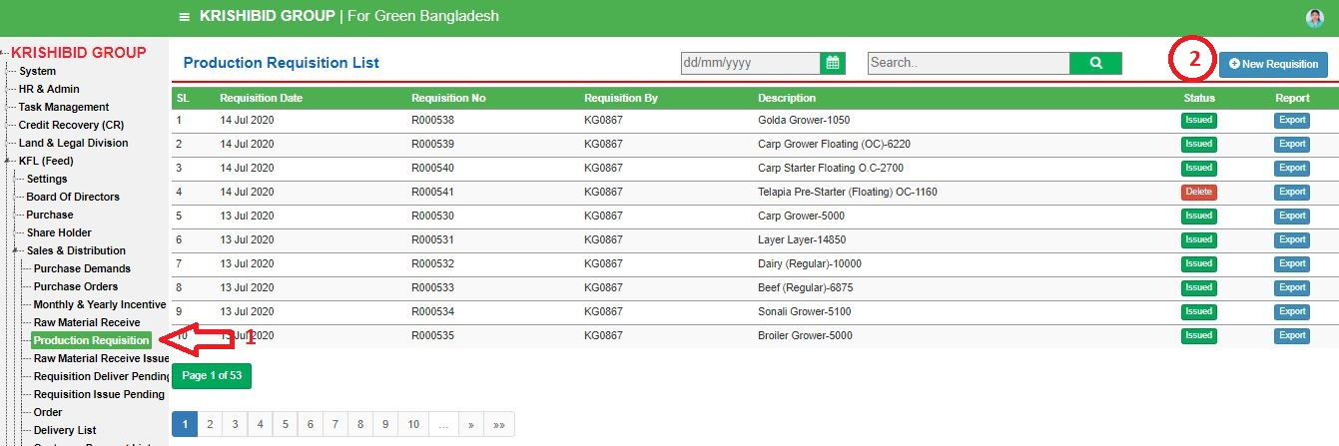

**Figure: 38 Production Requisition**

The following figure (Fig-38) shows options for Production Requisition.

* **Step-01:** Click on the **Production Requisition** section under **Settings (Feed) Menu** option. The following figure (Fig-28) shows the **Product of Feed** page.
* 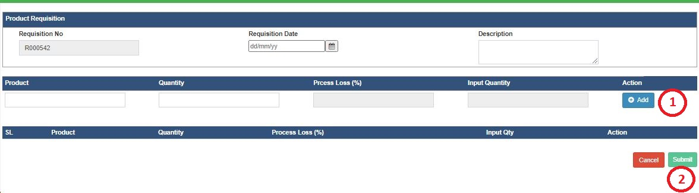**Step-02:** Click on +Add Requisition button to add new **Requisition** on the list. Enter any **“Requisition Date” or “Requisition No” or “Description”** in the search section and click “Enter” button to search any requisition.

**Figure: 39 Purchase Requisition Entry Page**

* Enter **‘Requisition Date’, ‘Description, ‘Product’, ‘Quantity’** and click “Add” button to add multiple product in list. User may delete individual item on adding list and Click on Submit button to save any new purchase requisition.

## **6.2 Requisition Deliver Pending**

**Figure: 40 Requisition Deliver Pending**

The following figure (Fig-40) shows options for Requisition Deliver Pending.

* **Step-01:** Click on the **Requisition Deliver pending** section under **Sales and Distribution (Feed)** option. The following figure (Fig-40) shows the **Requisition Deliver Pending** page.
* **Step-**02: Click on Deliver button for deliver any pending requisition against delivery.

## **6.3 Requisition Issue Pending**

**Figure: 41 Requisition Issue Pending**

The following figure (Fig-41) shows options for Requisition Issue Pending.

* **Step-01:** Click on the **Requisition Issue pending** section under **Sales and Distribution (Feed)** option. The following figure (Fig-40) shows the **Requisition Issue Pending** page.
* **Step-**02: Click on Issue button for issue any pending requisition against issue.

## **6.4 Order**

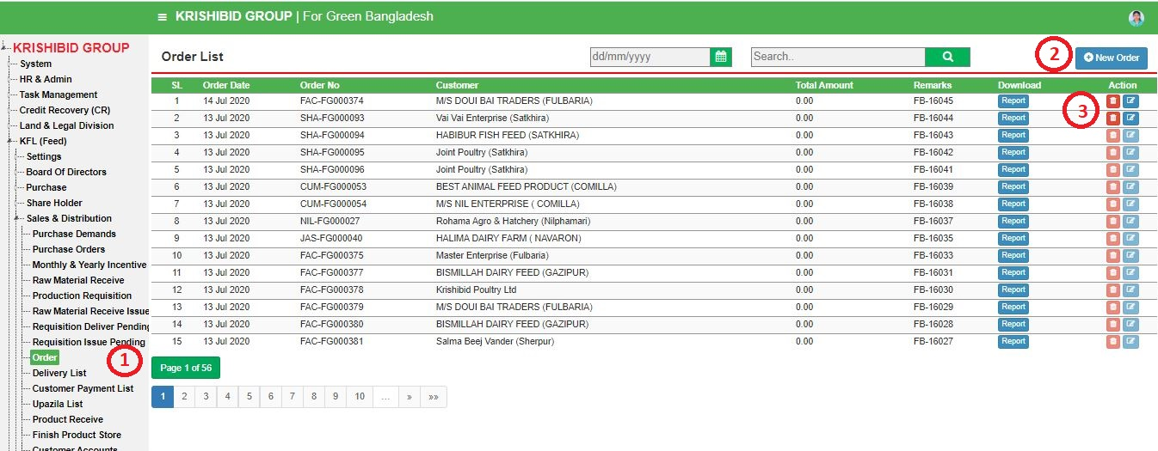**Figure: 42 Order**

The following figure (Fig-42) shows options for Order.

* **Step-01:** Click on the **Order** section under **Sales and Distribution (Feed)** option. The following figure (Fig-40) shows the **Order List** page.
* **Step-**02: Click on +New Order button for issue any order.

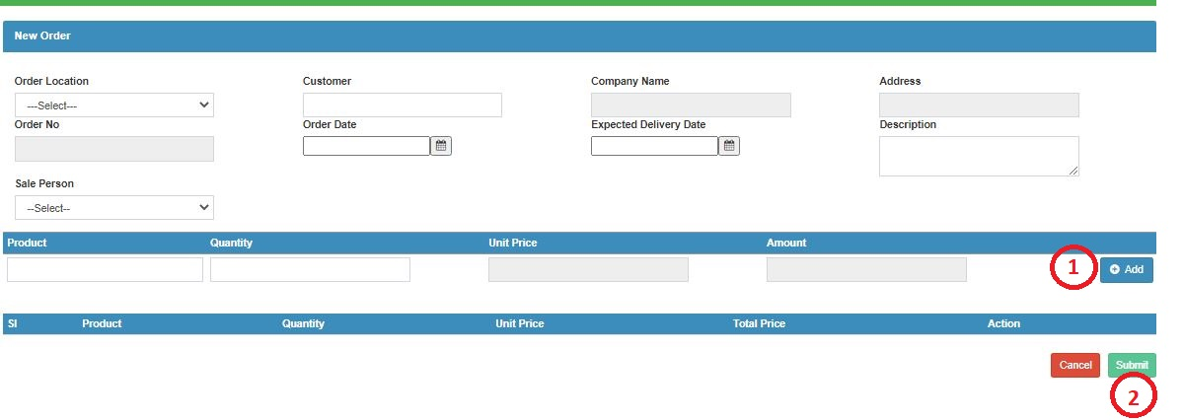**Figure: 43 Order Entry Page**

* Enter **‘Order Location’, ‘Customer’, ‘Order Date’, ‘Expected Delivery Date’, ‘Description’, ‘Sale Person’, ‘Product’, ‘Quality’** and click “Add” button to add multiple product in list. User may delete individual item on adding list and Click on Submit button to save any new order.

## **6.5 Delivery List**

**Figure: 44 Delivery List**

The following figure (Fig-43) shows options for Delivery.

* **Step-01:** Click on the **Delivery List** section under **Sales and Distribution (Feed)** option. The following figure (Fig-40) shows the **Delivery List** page.
* 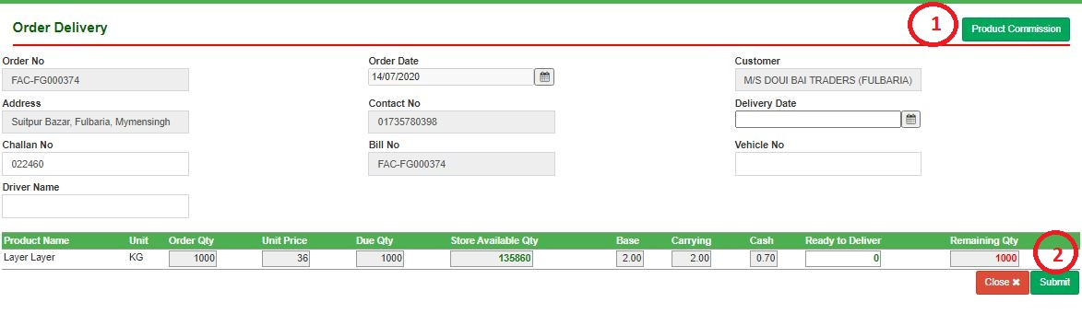**Step-**02: Click on Deliver button for deliver any order.

**Figure: 45 Delivery Entry Page**

* Enter **‘Delivery Date’, ‘Challan No’, ‘Vehicle No’, ‘Driver Name’, ‘Ready to Deliver’** and Click on Submit button to deliver multiple product in list.

## **6.6 Customer Payment List**

**Figure: 46 Customer Payment List**

The following figure (Fig-46) shows options for Customer Payment List.

* **Step-01:** Click on the **Customer Payment List** section under **Sales and Distribution (Feed)** option. The following figure (Fig-46) shows the **Customer Payment List** page.
* **Step-02:** Click on +New Payment button for issue any Customer payment. Enter any **“Transaction Date” or “Customer” or “Customer Code” or “Reference No”** in the search section and click Enter button to search any customer payment information.

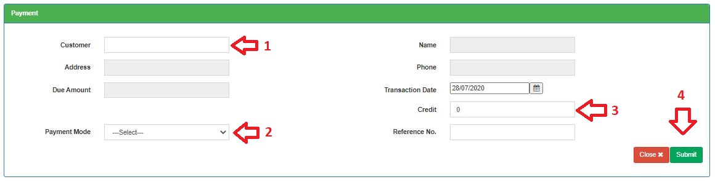**Figure: 47 Payment Entry Page**

* Enter **‘Customer’, ‘Transaction Date, ‘Credit, ‘Payment Mode, ‘Reference No’** and Click on Submit button to save any new payment entry against any customer.

## **6.7 Upazila List**

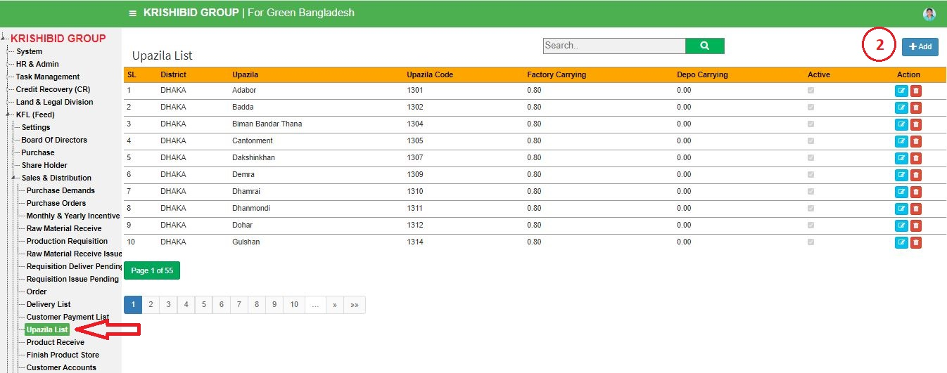

**Figure: 48 Upazila List**

The following figure (Fig-48) shows options for Upazila List.

* **Step-01:** Click on the **Upazila List** section under **Sales and Distribution (Feed)** option. The following figure (Fig-48) shows the **Upazila List** page.
* **Step-02:** Click on +New Payment button for issue any Customer payment. Enter any **“District” or “Upazila” or “Upazila Code”** in the search section and click Enter button to search any **Upazila** information.

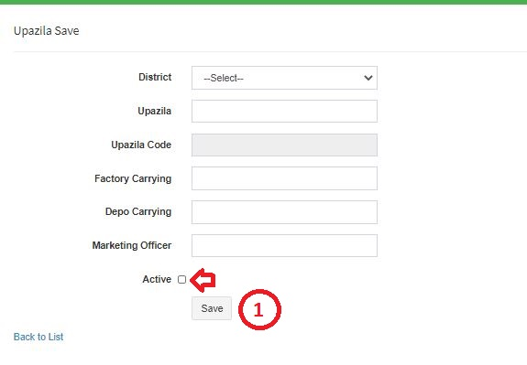**Figure: 49 Upazila Entry Page**

* Enter **‘District, ‘Upazila’, ‘Factory Carrying’, ‘Depo Carrying’, ‘Marketing Officer’** and check Active button then Click on Save button to save any new upazila entry.

## **6.8 Product Receive**

**Figure: 46 Product Receive**

The following figure (Fig-45) shows options for **Product Receive**.

* **Step-01:** Click on the **Product Receive** section under **Sales and Distribution (Feed)**  **Menu** option.
* **Step-02:** Enter any **“Code” or** **“Name” or** **“Address” or “Phone”** in the search section and click “Enter” button to search any individual customers account status.

## **6.9 Sales Return**

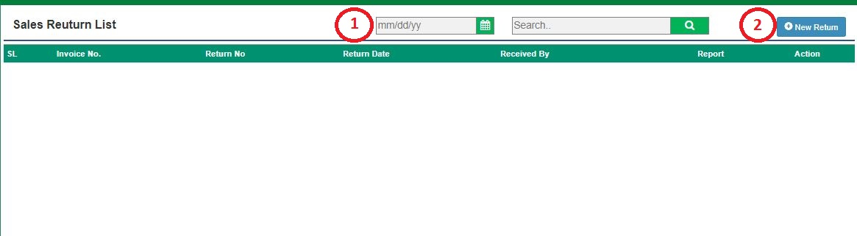

**Figure: 47 Sales Return**

The following figure (Fig-47) shows options for Sales Return.

* **Step-01:** Click on the **Sales Return** section under **Sales and Distribution (Feed)**  **Menu** option.
* **Step-02:** Enter any **“Invoice No” or “Return No” or “Return Date” or “Received by”** in the search section and click “Enter” button to search any received product. Click on “New Return” Button to add any new product return.

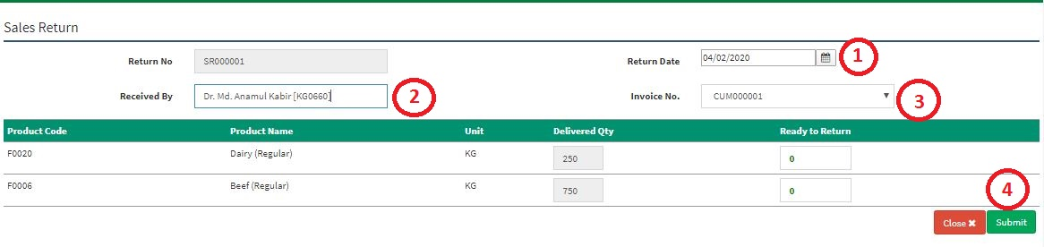**Figure: 48 Sales Return Entry Page**

* Enter **‘Supplier, ‘Return Date, ‘Received By, ‘Invoice No’, ‘Unit’, ‘Ready to Return’ click on Add button to load multiple Item on list** and Click on Submit button to save any new Sales Return.

## **6.10 Stock Transfer List**

**Figure: 49 Stock Transfer**

The following figure (Fig-47) shows options for Stock Transfer.

* **Step-01:** Click on the **Stock Transfer** section under **Sales and Distribution (Feed)** **Menu** option.
* 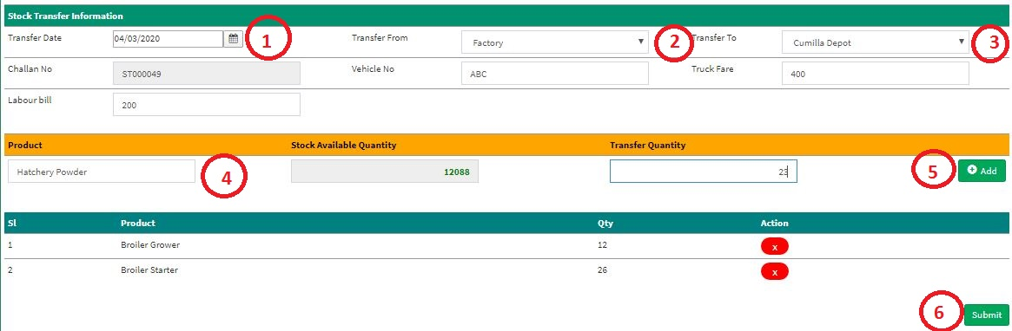**Step-02:** Enter any **“Transfer Date” or “Transfer From” or “Transfer To” or “Challan No” or “Vehicle No”** in the search section and click “Enter” button to search any received product. Click on “New Transfer” Button to add any new product transfer.

**Figure: 48 Sales Return Entry Page**

* Enter **‘Transfer Date, ‘Transfer From, ‘Transfer To, ‘Vehicle No, ‘Truck Fare, ‘Labour Bill’, ‘Product’, ‘Transfer Quantity’ click on Add button to load multiple Item on list** and Click on Submit button to save any new Product Transfer.

## **6.11 Stock Receive List**

**Figure: 49 Stock Receive**

The following figure (Fig-47) shows options for Stock Transfer.

* **Step-01:** Click on the **Stock Transfer** section under **Sales and Distribution (Feed)** **Menu** option.
* **Step-02:** Enter any **“Transfer Date” or “Transfer From” or “Transfer To” or “Challan No” or “Vehicle No”** in the search section and click “Enter” button to search any received product.

**Figure: 50 Stock Receive Entry Page**

* Enter **‘Transfer Date, ‘Transfer From, ‘Transfer To, ‘Vehicle No, ‘Truck Fare, ‘Labour Bill’, ‘Product’, ‘Transfer Quantity’ click on Add button to load multiple Item on list** and Click on Submit button to save any new Product Transfer.

## **6.12 Product Conversion List**

**Figure: 51 Product Conversion List**

The following figure (Fig-51) shows options for Product Conversion.

* **Step-01:** Click on the **Product Conversion List** section under **Sales and Distribution (Feed)** **Menu** option.
* **Step-02:** Enter any **“Invoice No” or “Customer Date” or “Convert From” or “Convert To”** in the search section and click Enter button to search any New RM Receive. Click on “New” Button to add any new product conversion.

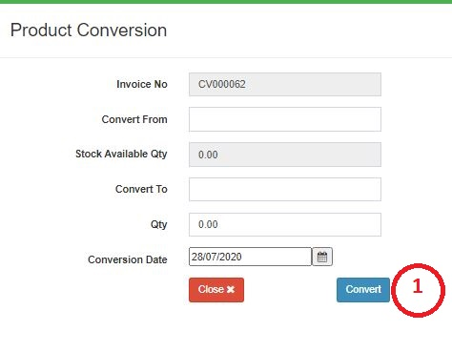

**Figure: 52 Product Conversion Entry Page**

* Enter **‘Convert No’, ‘Convert To’, ‘Qty’, ‘Conversion Date’** and Click on Convert button to save any new product conversion.

## **6.13 Product Conversion Approval List**

**Figure: 53 Product Conversion Approval List**

The following figure (Fig-53) shows options for Product Conversion Approval.

* **Step-01:** Click on the **Product Conversion List** section under **Sales and Distribution (Feed)** **Menu** option.
* **Step-02:** Enter any **“Invoice No” or “Customer Date” or “Convert From” or “Convert To”** in the search section and click Enter button to search any New RM Receive. Click on “New” Button to add any new product conversion same as Conversion list.

## **6.14 Stock Adjustment**

**Figure: 54 Stock Adjustment List**

The following figure (Fig-54) shows options for Stock Adjustment.

* **Step-01:** Click on the **Stock Adjustment List** section under **Sales and Distribution (Feed)** **Menu** option.
* 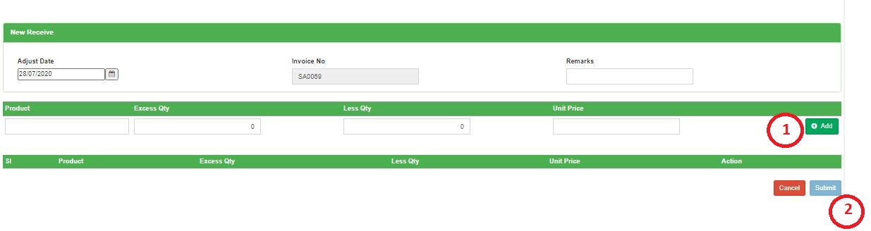**Step-02:** Enter any **“Invoice No” or “Adjust Date”** in the search section and click Enter button to search any New RM Receive. Click on “New Adjustment” Button to add any new product adjustment list.

**Figure: 55 Product Adjustment Entry Page**

* Enter **‘Adjust Date’, ‘Product’, ‘Excess Qty’, ‘Less Qty’, ‘Unit Price’** and Click on Submit button to save any new product conversion.

## **6.15 RM Order**

**Figure: 57 RM Order**

The following figure (Fig-54) shows options for RM Order.

* **Step-01:** Click on the **RM Order List** section under **Sales and Distribution (Feed)** **Menu** option.
* **Step-02:** Enter any **“Order Date”, “Order No” or “Customer”** in the search section and click Enter button to search any New RM Receive. Click on “New Order” Button to add any new product order list.

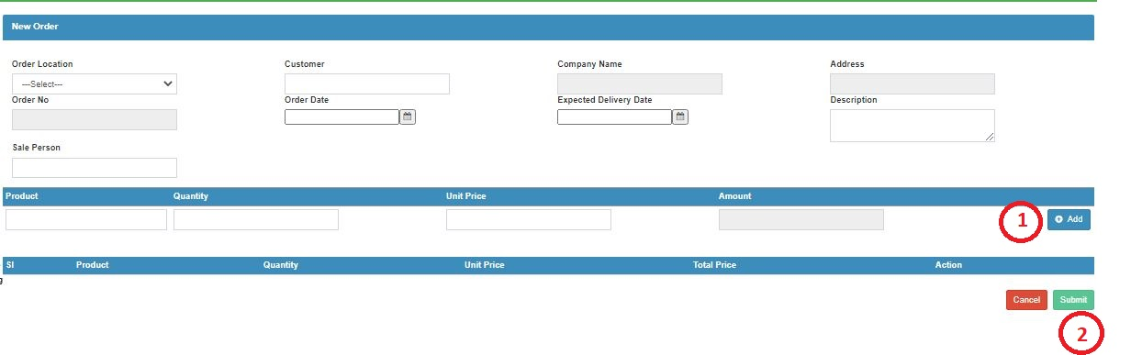**Figure: 58 RM Order Entry Page**

* Enter **‘Order Location’, ‘Customer’, ‘Order Date’, ‘Expected Delivery Date’, ‘Description’, ‘Product’, ‘Quantity’, ‘Unit Price’ then** click on Add button to add multiple product and Click on Submit button to save any new rm.

## **6.16 Raw Material Opening**

**Figure: 59 Raw Material Opening**

The following figure (Fig-59) shows options for RM Opening.

* **Step-01:** Click on the **RM Opening List** section under **Sales and Distribution (Feed)** **Menu** option.
* **Step-02:** Enter any **“Receive Code”, “Store” or “Receive Date”** in the search section and click Enter button to search any New RM opening. Click on “New Receive” Button to add any new rm opening list.

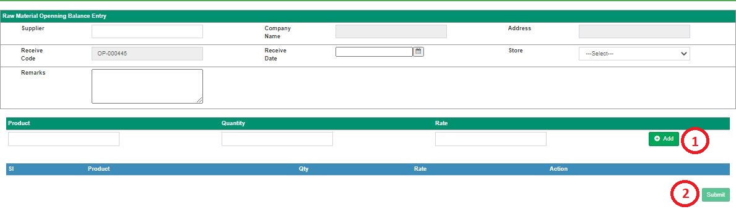**Figure: 60 RM Opening Balance Entry Page**

* Enter **‘Supplier’, ‘Receive Date’, ‘Store’, ‘Remarks’ then** click on Add button to add multiple product and Click on Submit button to save any new rm.

## **6.17 RM Delivery**

**Figure: 61 Raw Material Deliver**

The following figure (Fig-61) shows options for RM Deliver.

* **Step-01:** Click on the **RM Deliver List** section under **Sales and Distribution (Feed)** **Menu** option.
* **Step-02:** Enter any **“Receive Code”, “Store” or “Receive Date”** in the search section and click Enter button to search any New RM opening. Click on “New Receive” Button to add any new rm opening list.

## **6.18 Finish Product Opening**

**Figure: 62 Finish Product Opening**

The following figure (Fig-62) shows options for Finish Product Opening.

* **Step-01:** Click on the **Finish Product Opening List** section under **Sales and Distribution (Feed)** **Menu** option.
* **Step-02:** Enter any **“Receive Code”, “Store” or “Receive Date”** in the search section and click Enter button to search any New RM opening. Click on “New Receive” Button to add any new rm opening list.

# 7. Reports (Feed)

## **7.1 Finish Product Stock**

**Figure: 63 Finish Product Stock**

The following figure (Fig-63) shows options for Finish Product Stock.

* **Step-01:** Click on the **Finish Product Stock Report** section under **Reports (Feed)** **Menu** option.
* **Step-02:** Enter any **“From Date”, “To Date” or “Stock”** and click Export button to export any finish product stock report.

## **7.2 Raw Material Stock**

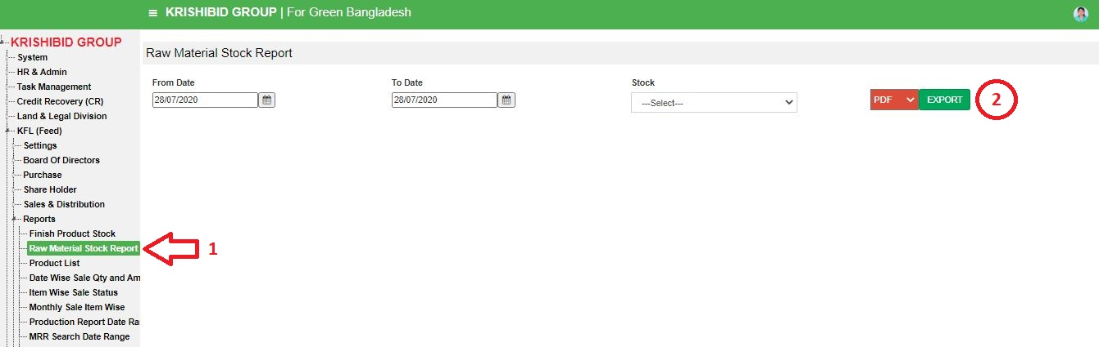**Figure: 64 Raw Material Stock**

The following figure (Fig-64) shows options for Raw material Stock report.

* **Step-01:** Click on the **Raw Material Stock Report** section under **Reports (Feed)** **Menu** option.
* **Step-02:** Enter any **“From Date”, “To Date” or “Stock”** and click Export button to export any raw material stock report.

## **7.3 Product List**

**Figure: 65 Product List**

The following figure (Fig-65) shows options for Product List Stock report.

* **Step-01:** Click on the **Product List Report** section under **Reports (Feed)** **Menu** option.
* **Step-02:** Enter any **“Product Type”** and click Export button to export any raw product stock report.

## **7.4 Date wise Sale Qty. and Amount**

**Figure: 66 Date wise Sale Quantity and Amount**

The following figure (Fig-65) shows options for **Date wise Sale Quantity and Amount** report.

* **Step-01:** Click on the **Date wise Sale Quantity and Amount Report** section under **Reports (Feed)** **Menu** option.
* **Step-02:** Enter any **“From Date” and “To Date”** and click Export button to export any raw product stock report.

## **7.5 Item wise Sale Status**

**Figure: 67 Item wise Sale Status**

The following figure (Fig-65) shows options for **Item wise Sale Status** report.

* **Step-01:** Click on the **Item wise Sale Status Report** section under **Reports (Feed)** **Menu** option.
* **Step-02:** Enter any **“From Date” and “To Date”** and click Export button to export any item wise sale status report.

## **7.6 Monthly Sale Item wise**

**Figure: 68 Monthly Sale Item wise**

The following figure (Fig-65) shows options for **Monthly Sale Item wise** report.

* **Step-01:** Click on the **Monthly Sale Item wise** **Report** section under **Reports (Feed)** **Menu** option.
* **Step-02:** Enter any **“Year” and “Month”** and click Export button to export any **Monthly Sale Item wise** report.

## **7.7 Production Report Date Range wise**

**Figure: 69 Production Report Date Range wise**

The following figure (Fig-65) shows options for **Production Report Date Range wise** report.

* **Step-01:** Click on the **Production Report Date Range wise** **Report** section under **Reports (Feed)** **Menu** option.
* **Step-02:** Enter any **“From Date” and “To Date”** and click Export button to export any **Production Report Date Range wise** report.

## **7.8 MRR Search Date wise Report**

**Figure: 70 MRR Search Date Range wise**

The following figure (Fig-65) shows options for **MRR Search Date Range wise** report.

* **Step-01:** Click on the **MRR Search Date Range wise** **Report** section under **Reports (Feed)** **Menu** option.
* **Step-02:** Enter any **“From Date” and “To Date”** and click Export button to export any **MRR Search Date Range wise** report.

## **7.9 Depot wise Sale**

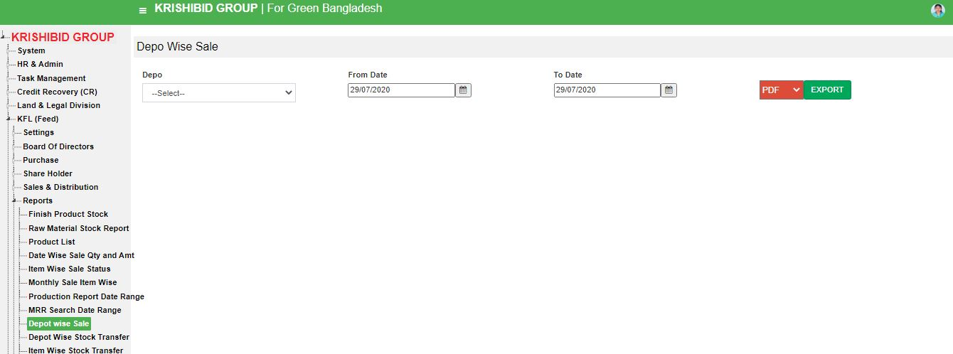

**Figure: 71 Depot wise Sale**

The following figure (Fig-65) shows options for **Depot wise Sale** report.

* **Step-01:** Click on the **Depot wise Sale Report** section under **Reports (Feed)** **Menu** option.
* **Step-02:** Enter any **“From Date” and “To Date”** and click Export button to export any **Depot wise Sale** report.

## **7.10 Depot wise Stock Transfer**

**Figure: 72 Depot wise Stock Transfer**

The following figure (Fig-65) shows options for **Depot wise Stock Transfer** report.

* **Step-01:** Click on the **Depot wise Stock Transfer Report** section under **Reports (Feed)** **Menu** option.
* **Step-02:** Enter any **“From Date” and “To Date”** and click Export button to export any **Depot wise Stock Transfer** report.

## **7.11 Item wise Stock Transfer**

**Figure: 73 Item wise Stock Transfer**

The following figure (Fig-65) shows options for **Item wise Stock Transfer** report.

* **Step-01:** Click on the **Item wise Stock Transfer Report** section under **Reports (Feed)** **Menu** option.
* **Step-02:** Enter any **“Depot”,** **“From Date” and “To Date”** and click Export button to export any **Item wise Stock Transfer** report.

## **7.12 Customer Report**

**Figure: 74 Customer Report**

The following figure (Fig-65) shows options for **Customer** report.

* **Step-01:** Click on the **Customer Report** section under **Reports (Feed)** **Menu** option.
* **Step-02:** Enter any **“Company”** and click Export button to export any **Customer** report.

## **7.13 Glory Support Report**

**Figure: 75 Glory Support Report**

The following figure (Fig-75) shows options for **Glory Support Report**.

* **Step-01:** Click on Glory Support Report section under **Reports (Feed)** **Menu** option.
* **Step-02:** Enter any **“VendorId”,** **“From Date” and “To Date”** and click Export button to export any **Glory Support Report**.

# 8. Accounting (Feed)

## **8.1 Chart of Accounts**

**Figure: 76 Chart of Accounts**

The following figure (Fig-75) shows options for **Chart of Accounts**.

* **Step-01:** Click on **Chart of Accounts** section under **Accounting (Feed)** **Menu** option.
* **Step-02:** Click on Export button to export feed **Chart of Accounts**.

## **8.2 Voucher List**

**Figure: 77 Voucher List**

The following figure (Fig-54) shows options for RM Order.

* **Step-01:** Click on the **RM Order List** section under **Sales and Distribution (Feed)** **Menu** option.
* 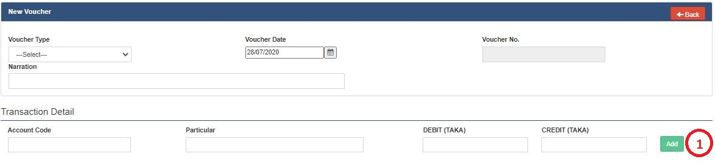**Step-02:** Enter any **“Order Date”, “Order No” or “Customer”** in the search section and click Enter button to search any New RM Receive. Click on “New Voucher” Button to add any new voucher list.

**Figure: 78 Voucher Entry Page**

* Enter **‘Voucher Type’, ‘Voucher Date’, ‘Narration’, ‘Account Code’, ‘Particular’, ‘Debit’, ‘Credit’** thenclick on Add button to add multiple product and Click on Add button to save any new rm.

# 9. Accounting Reports (Feed)

## **9.1 General Ledger**

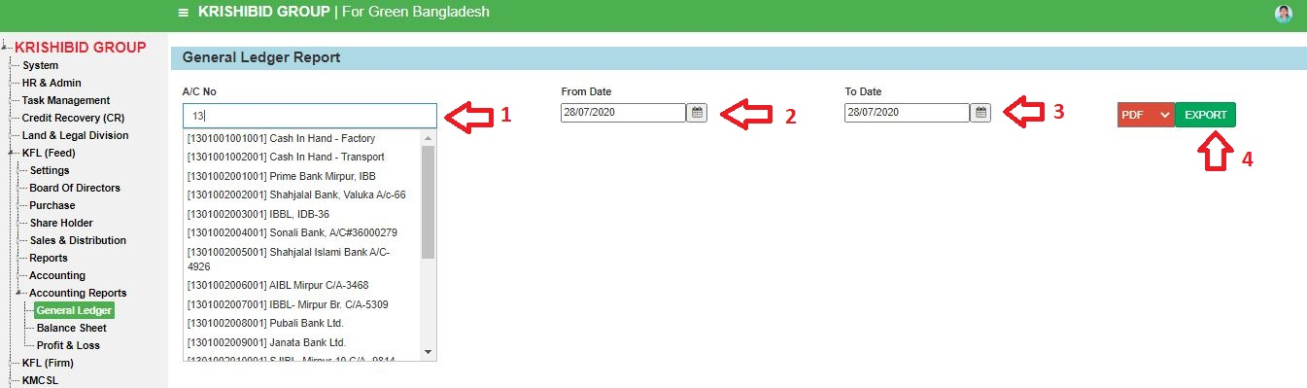

**Figure: 79 General Ledger**

The following figure (Fig-75) shows options for **General Ledger**.

* **Step-01:** Click on **General Ledger** section under **Reports (Feed)** **Menu** option.
* **Step-02:** Enter any **“A/C No”,** **“From Date” and “To Date”** and click Export button to export any **General Ledger**.

## **9.2 Balance Sheet**

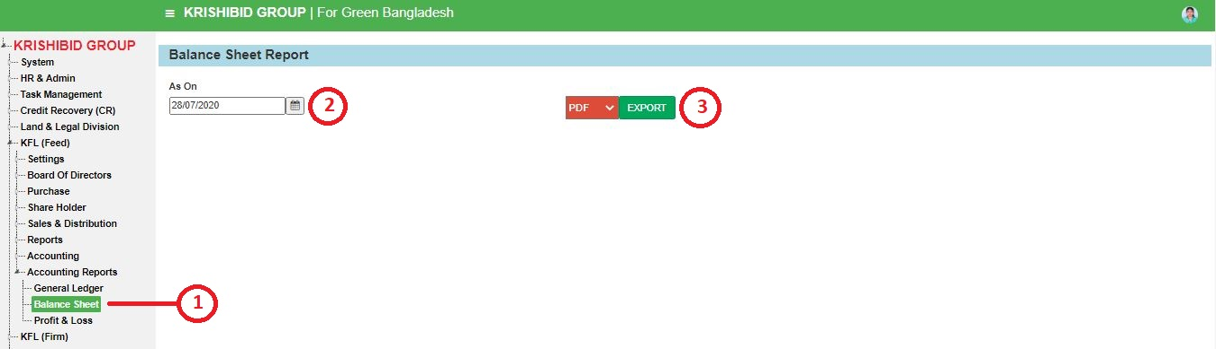

**Figure: 80 Balance Sheet**

The following figure (Fig-75) shows options for **Balance Sheet**.

* **Step-01:** Click on **Balance Sheet** Report section under **Reports (Feed)** **Menu** option.
* **Step-02:** Enter any **“As On”** and click Export button to export any **Balance Sheet**.

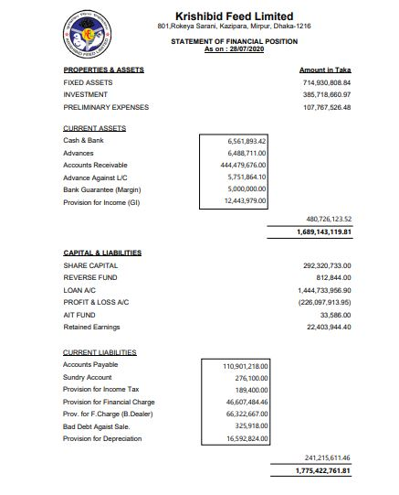**Figure: 81 Balance Sheet Report**

## **9.3 Profit & Loss**

**Figure: 82 Profit & Loss**

The following figure (Fig-82) shows options for **Profit & Loss**.

* **Step-01:** Click on Glory Support Report section under **Reports (Feed)** **Menu** option.
* **Step-02:** Enter any **“From Date” and “To Date”** and click Export button to export any **Profit & Loss.**

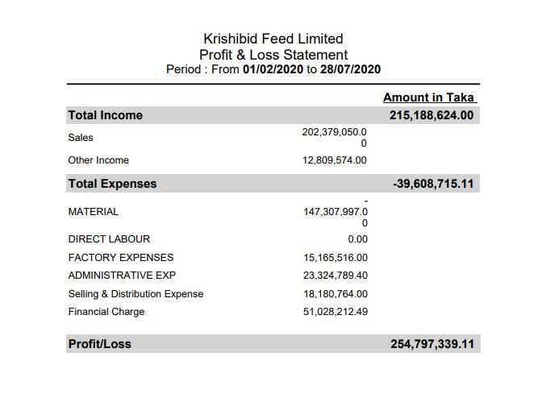

**Figure: 83 Profit & Loss Report**